SECURITY CHECK-IN - DOWNTOWN LOS ANGELES OFFICE

Capital Group Companies Onsite contact:
333 South Hope Street, 54th Floor Joanne Rose (213) 486-9056
Los Angeles, CA 90071 jonr@capgroup.com

- Please present a photo ID to security and you will be given access to the 54th floor.
Event will be held in Conference Room 54W.

MAP

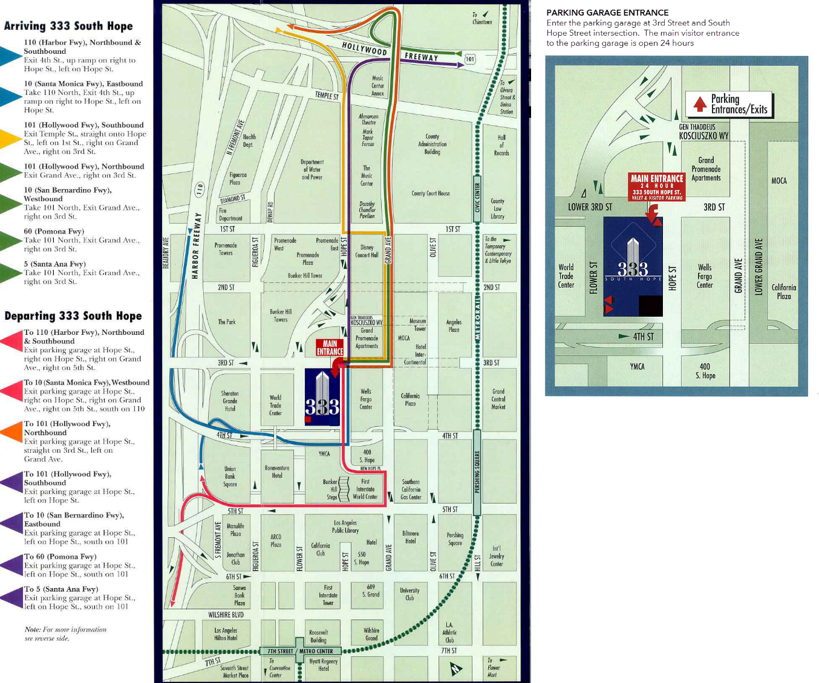

OTHER INFORMATION

- Transportation:
  - Parking: Visitor parking garage entrance on 3rd St and Hope St. Park on Level B. Take elevator to Level P (Plaza). Turn right, to check-in with Security.

  - Taxis are readily available and lined up in front of the building daily.

